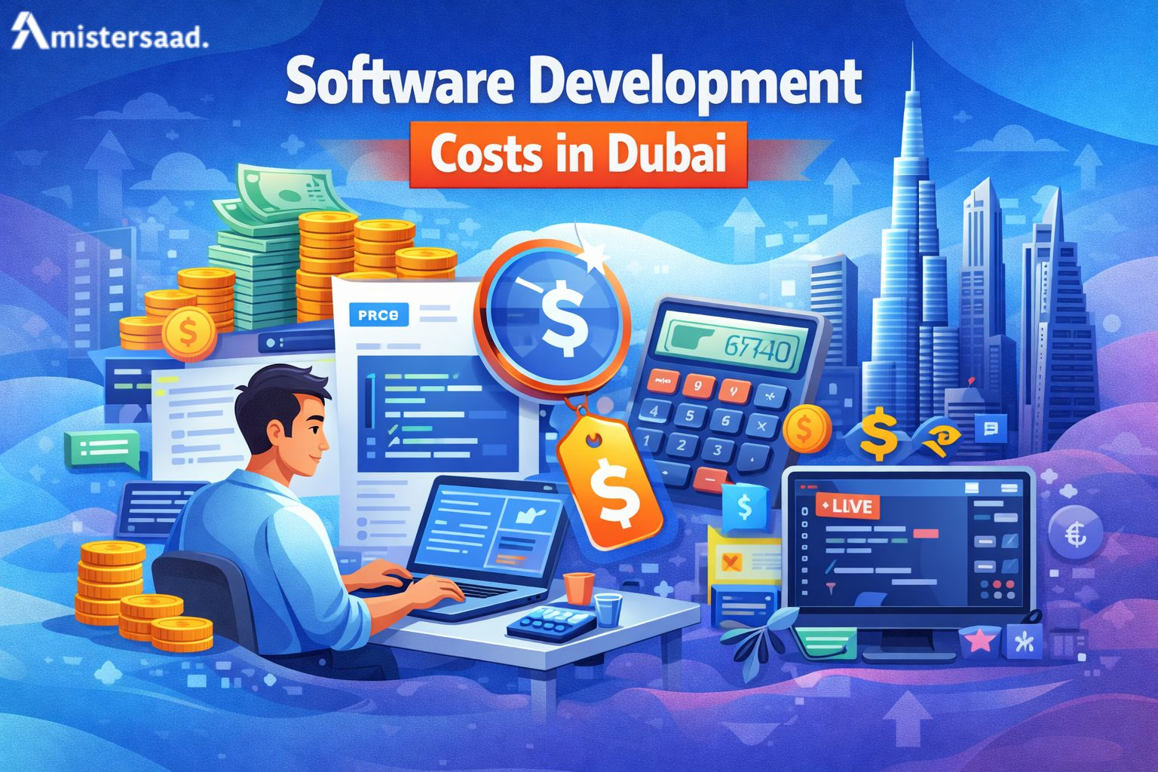


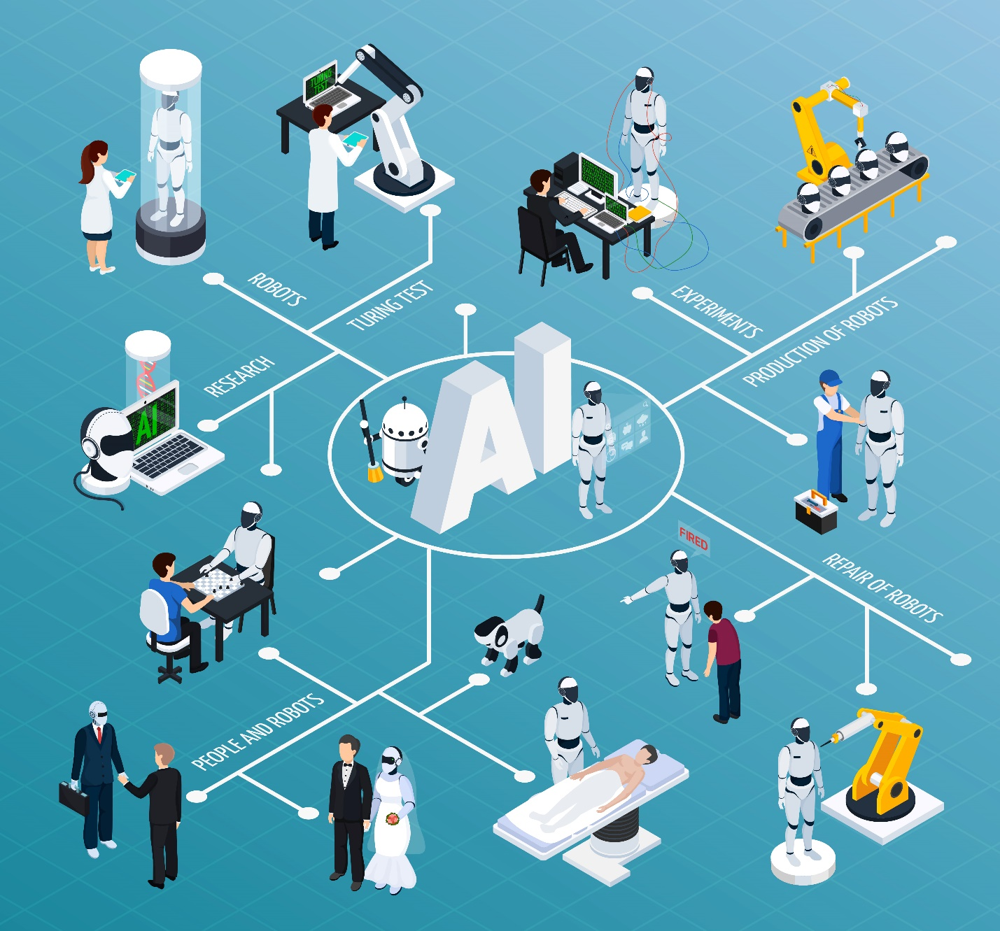

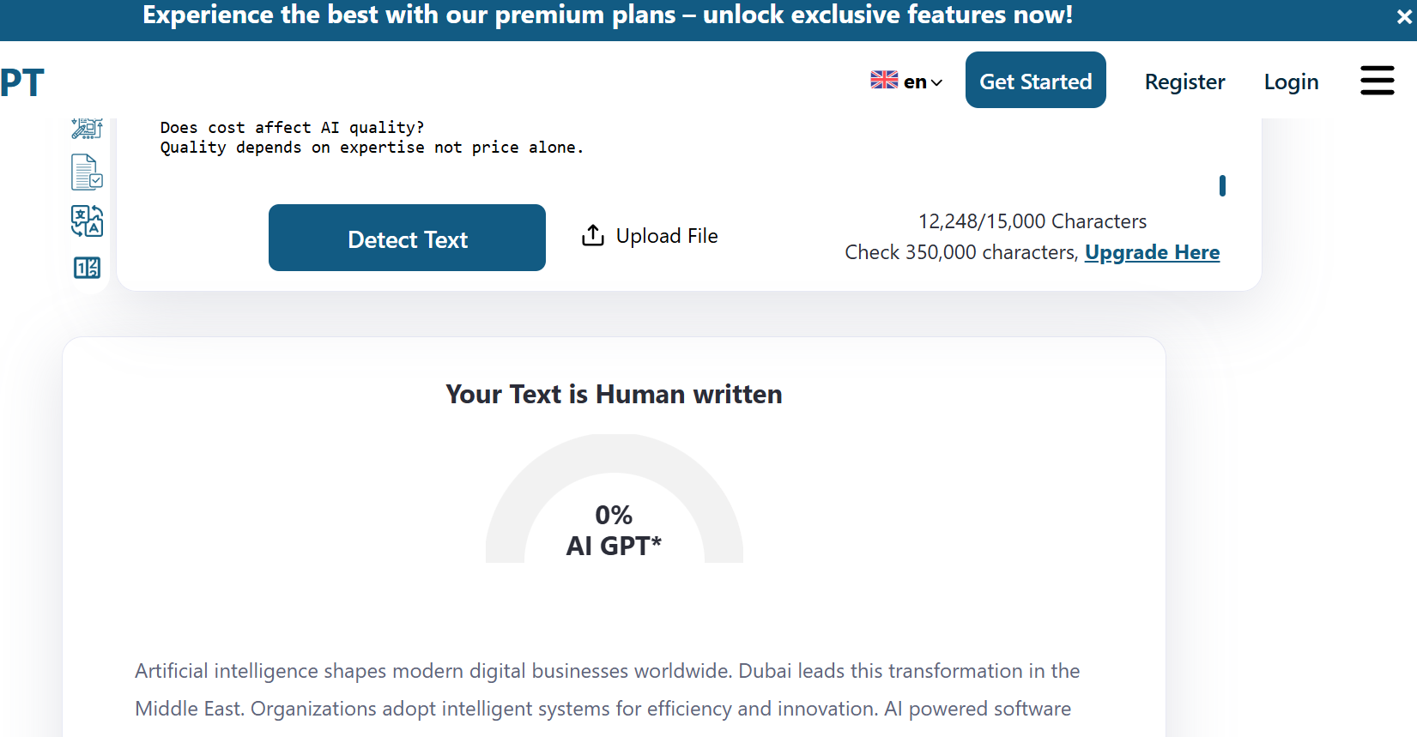
How Much Does AI Software Development Cost in Dubai, UAE (2026 Guide)
Focus Keyword: AI Software Development
Meta title: AI Software Development Costs in Dubai, UAE (2026 Guide)
Meta description: Explore AI software development costs in Dubai, UAE for 2026. Get insights on pricing factors, project scope, technology stack, and expert development rates.
Feature Image:
Introduction
Artificial intelligence shapes modern digital businesses worldwide. Dubai leads this transformation in the Middle East. Organizations adopt intelligent systems for efficiency and innovation. AI powered software improves decision accuracy and speed. Many companies now plan AI investments carefully. Dubai businesses rapidly adopt intelligent digital solutions. Many companies connect AI systems with mobile platforms. This demand increases App development dubai mobile solutions. Mobile based AI tools improve accessibility and operational speed. Businesses prefer unified digital ecosystems for growth.
Cost clarity becomes essential for planning success. Dubai offers advanced infrastructure and skilled talent. However, pricing varies by project scope. Understanding cost drivers avoids budget surprises. This guide explains cost elements clearly. Readers will learn pricing ranges and influencing factors. The article also compares regional development rates. Practical tips help reduce development expenses.

What Is AI Software Development?
AI software development creates systems that mimic human intelligence. These systems learn from data patterns. Machine learning models’ power predictive capabilities. Natural language processing enables human like communication. Computer vision allows visual data understanding. Chatbots automate customer interactions. Predictive analytics supports forecasting decisions. AI products vary by business need. Examples include recommendation engines and fraud detection. Voice assistants also use AI models. These solutions require training data and algorithms. Developers design logic for automated decisions. AI software integrates with existing platforms. Testing ensures reliable outputs. Continuous learning improves performance over time. Businesses gain efficiency through intelligent automation. AI systems reduce manual workload. Development complexity impacts cost significantly. Understanding basics helps cost estimation accuracy.

Why Dubai UAE Is a Hotspot for AI Projects
Dubai invests heavily in digital innovation. Government initiatives support artificial intelligence growth. The Dubai AI Strategy promotes smart solutions. Smart city programs drive technology adoption. Businesses receive regulatory support. The investment environment encourages innovation. Start-ups and enterprises collaborate actively. AI adoption spans healthcare finance and logistics. Retail and real estate also benefit. Infrastructure supports cloud computing needs. Data centres ensure reliable performance. Skilled professionals relocate to Dubai. International firms establish regional offices. Market demand drives competitive development services. Dubai connects global and regional markets. AI projects gain visibility and scalability. Businesses trust Dubai for innovation leadership. This ecosystem influences development pricing positively. Many enterprises rely on app development dubai expertise This integration improves AI deployment efficiency. Market readiness attracts long term investments.

Factors That Affect AI Software Development Cost
The total cost of building an AI system isn’t fixed—it depends on many variables. Below are the major factors that influence the budget:

Project Scope & Complexity
The biggest determinant of AI development cost is what the system is expected to do.
- Basic AI solutions (chatbots, rule-based automation, simple recommendation engines) cost significantly less.
- Advanced AI systems (computer vision, predictive analytics, NLP-powered platforms, autonomous decision-making) require complex architecture, more data, and longer development cycles.
Impact on cost:
Simple AI → Lower cost
Enterprise-grade AI → High cost

Data Availability and Quality
Data quality determines AI effectiveness. Clean data reduces preparation costs. Raw data requires pre-processing efforts. Data collection consumes time resources. Labelling data increases expenses. Poor data delays development cycles. Secure storage adds infrastructure costs. Data privacy compliance requires safeguards. Businesses often underestimate data preparation. Quality datasets improve model accuracy. Better data reduces retraining needs. External data sourcing increases budget. Structured data lowers engineering workload. Data readiness influences total investment. Early assessment prevents cost overruns.

Development Team Model
Team structure affects pricing significantly. In house teams cost more long term. Outsourcing offers flexible pricing. Freelancers reduce short term expenses. Team experience impacts development speed. Senior engineers demand higher rates. Project managers add coordination value. Larger teams increase overhead costs. Communication efficiency affects timelines. Dedicated teams ensure accountability. Hybrid models balance cost and quality. Businesses choose based on budget tolerance. Team location influences hourly rates. Right model ensures cost efficiency. Some businesses prefer flexible hiring models. Short term projects benefit from independent specialists. Many startups choose a Freelance app developer dubai. This option controls budget while maintaining quality. Freelancers support faster project execution cycles.

Infrastructure and Tools
Infrastructure supports AI processing needs. Cloud services handle computation loads. Storage costs depend on data volume. AI frameworks may require licenses. GPUs increase processing efficiency. Compute power affects monthly expenses. Tool selection impacts performance quality. Open source tools reduce licensing fees. Managed services simplify deployment. Monitoring tools add operational costs. Scalability requires robust infrastructure. Security tools ensure compliance standards. Infrastructure planning influences long term budgets. Proper selection avoids unnecessary expenses.

Typical AI Development Cost Breakdown in Dubai

Below is an estimated cost breakdown for AI software development projects in Dubai:

Discovery & Planning (10–15%)
- Requirement analysis
- Use-case validation
- Feasibility study
- Cost estimation
Estimated Cost: AED 30,000 – AED 80,000

Data Engineering & Preparation (20–30%)
- Data collection
- Data cleaning & labelling
- Data pipeline setup
Estimated Cost: AED 60,000 – AED 200,000+

AI Model Development (25–35%)
- Model selection & training
- Algorithm development
- Testing & optimization
Estimated Cost: AED 100,000 – AED 350,000+

Software Development & Integration (15–25%)
- Backend development
- API creation
- Frontend/dashboard integration
- System integrations
Estimated Cost: AED 70,000 – AED 250,000

Infrastructure & Cloud Setup (5–10%)
- Cloud configuration
- GPU/compute resources
- Security setup
Estimated Cost: AED 20,000 – AED 100,000 (excluding ongoing cloud usage)

Testing, Deployment & Optimization (5–10%)
- Model validation
- Performance testing
- Deployment & monitoring
Estimated Cost: AED 25,000 – AED 80,000

Maintenance & Continuous Improvement (Ongoing)
- Model retraining
- Bug fixes
- Feature enhancements
Monthly Cost: AED 10,000 – AED 40,000+

Minimum Viable AI Projects
MVP projects validate AI feasibility. These systems focus on core features. Development timelines remain short. Costs range between twenty thousand dollars. MVPs include basic models and interfaces. Limited data processing is required. Testing focuses on functionality only. These projects suit start-ups and pilots. MVPs reduce financial risk. Businesses test market response quickly. Feature expansion occurs later. MVPs avoid heavy infrastructure investment. Simple automation fits this category. Proof of concept systems dominate MVPs. Early feedback guides future development.

Mid Level AI Systems
Mid level systems offers advanced functionality. These include recommendation engines. Analytics dashboards enhance insights. Development complexity increases moderately. Costs range from fifty thousand dollars. Integration with existing systems occurs. APIs support data exchange. User interfaces improve usability. Testing covers performance scenarios. Data pipelines require optimization. These systems support business operations. Retail and finance often use them. Mid level projects balance cost and value. Development timelines span several months. Businesses achieve measurable ROI.

Enterprise Scale AI Platforms
Enterprise platforms support large operations. These systems manage massive datasets. Advanced security features are mandatory. Costs exceed one hundred fifty thousand dollars. Deployment spans multiple departments. Custom workflows enhance flexibility. Continuous model training improves accuracy. Compliance standards require audits. Performance monitoring ensures reliability. These platforms deliver strategic advantages. Logistics and healthcare rely on them. ROI improves through automation scale. Development requires experienced teams. Timelines extend beyond six months. Long term value justifies investment.

Ongoing Support And Maintenance
AI systems need continuous support. Models require regular retraining. Data changes affect performance. Monitoring ensures accuracy levels. Monthly support costs apply. Annual maintenance contracts exist. Security updates protect data integrity. SLA agreements define response times. Cloud usage adds recurring expenses. Performance optimization continues post launch. Businesses allocate operational budgets. Support ensures system longevity. Neglect increases failure risks. Maintenance protects initial investment. Long term planning remains essential.

AI Development Rates In Dubai Versus Other Regions
Dubai offers premium development services. Rates reflect infrastructure quality. Hourly costs range moderately. United States rates remain higher. Europe follows similar pricing. South Asia offers lower costs. Outsourcing reduces budget pressure. Dubai provides regional expertise benefits. Communication remains efficient. Time zone alignment helps collaboration. Quality standards remain high. Cost differences reflect talent availability. Businesses choose based on priorities. Local compliance adds value. Global comparison aids budgeting decisions.

How To Reduce Your AI Development Costs
Start with a focused MVP. Avoid unnecessary features initially. Use pre trained models when possible. Open source frameworks reduce expenses. Hybrid cloud solutions balance costs. Reuse existing data assets. Define requirements clearly. Choose experienced consultants. Local partnerships reduce coordination delays. Iterative development prevents waste. Budget monitoring ensures control. Automation tools save time. Planning reduces rework costs. Smart decisions optimize investment outcomes.

Questions To Ask Before Hiring AI Developers
Ask about similar project experience. Evaluate data handling capabilities. Confirm security compliance knowledge. Discuss post launch support plans. Understand pricing structures clearly. Fixed models offer predictability. Hourly models offer flexibility. Retainers support long term needs. Ask about communication processes. Review past project outcomes. Check technical certifications. Transparency ensures trust. Proper questions prevent future issues.

Conclusion
AI development costs vary by scope and strategy. Dubai offers a mature innovation ecosystem. Businesses benefit from skilled professionals. Budget clarity ensures project success. Understanding cost drivers avoids surprises. Smart planning maximizes ROI. Starting small reduces risk. Scaling later improves value. Dubai supports global quality standards. AI investments require long term thinking. Proper budgeting strengthens outcomes. Strategic choices define success. Businesses should plan wisely. AI remains a powerful growth tool.

FAQs
How much does AI development cost per hour in Dubai?
Rates vary based on expertise and project needs.
Do costs include data preparation?
Some providers charge separately for data work.
Which industries pay the most for AI?
Finance healthcare and logistics invest heavily.
Is outsourcing cheaper than in house teams?
Outsourcing often reduces long term costs.
Does cost affect AI quality?
Quality depends on expertise not price alone.

